Project Design Phase
Solution Architecture

Date | 03 October 2026
Team ID | Team 12
Project Name | Streamlining IT Procurement: Automating Standard Laptop Orders with Flow Designer
Maximum Marks | 4 Marks

Solution Architecture:
Solution architecture is a complex process that bridges the gap between the IT procurement problem and the proposed ServiceNow Flow Designer solution. Its goals are to:
● Find the best technology solution to automate the standard laptop procurement process and reduce delays, manual work, and errors.
● Describe the structure and behaviour of the ServiceNow workflow, including request submission, manager approval, inventory checking, procurement, and status notifications.
● Define the features and requirements such as the laptop request form, automated approval routing, inventory validation, procurement request creation, asset updates, and notifications.
● Provide specifications for implementing and managing the automated workflow so that employees, managers, IT, and procurement teams can track and process laptop requests efficiently.

Example - Solution Architecture Diagram:
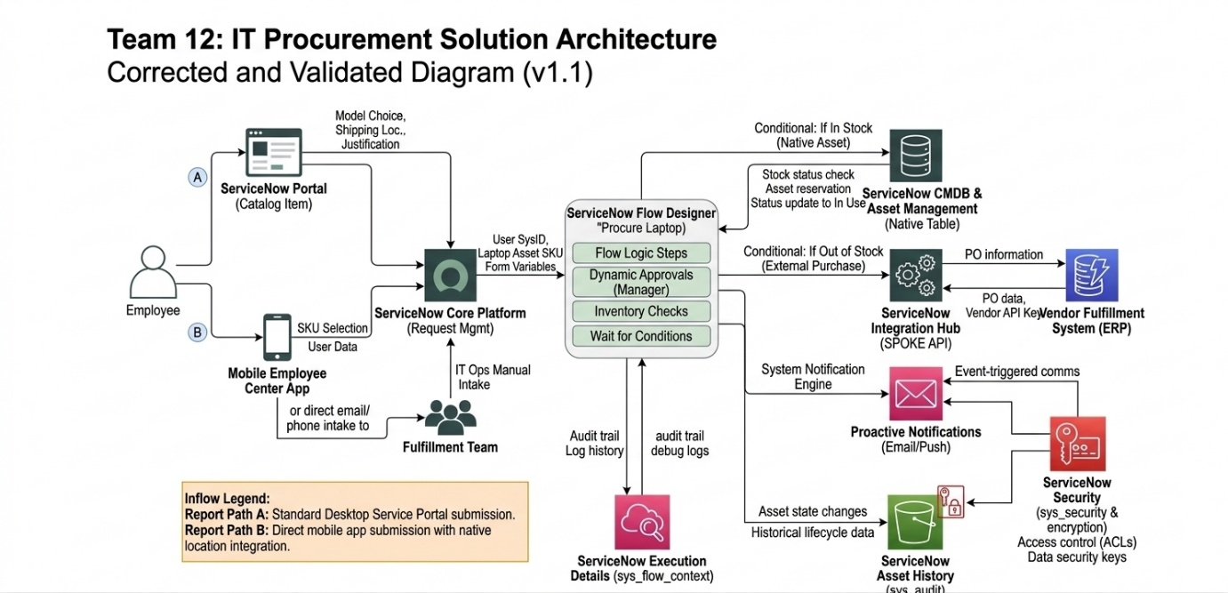
Figure 1: Architecture and data flow of the voice patient diary sample application
Reference: https://aws.amazon.com/blogs/industries/voice-applications-in-clinical-research-powered-by-ai-on-aws-part-1-architecture-and-design-considerations/

